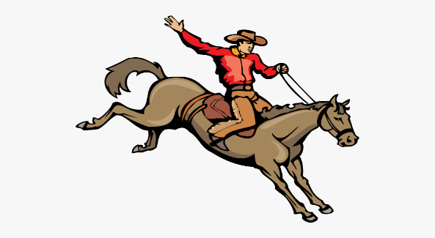

2025-2026 Bowring Wrangler Basketball Schedule

Nov. 10th-15th Shidler Tournament 7&8 Girls Only

Nov. 18th Osage Hills Here 4:30

Nov 20th Peckham There 4:30

Dec. 2nd Osage Hills There 4:30

Dec. 9th Kildare Here 4:30

Dec 15th Prue There 5:00

Jan. 5th-10th  5th-6th Only Bowring Tournament

Jan. 13th Kildare There 4:30

Jan 15th Prue Here 5:00

Jan. 20th Wynona Here only 2 games 5th-8th will play together 5:00

Jan. 22nd Wynona There only 2 games 5th-8th will play together 5:00

Jan 26th Peckham Here 4:30

Jan 31st -Feb 7 ORES AREA

Feb 12-14 ORES STATE